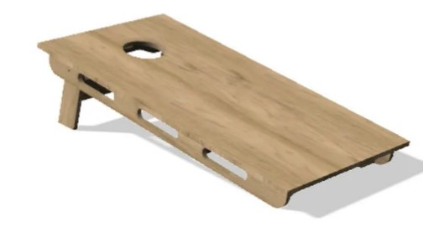

Keep Athens Beautiful
1st Annual Corn Hole Tournament
^{$1,000 in guaranteed payouts}
Saturday, March 4, 2023
Henderson County Regional Fair Park, Athens Texas

REGISTRATION FORM
Contact Name _______________________________Company___________________________________
Mailing Address________________________________________________________________________
City__________________________________State________Zip Code____________________________
Phone_____________________Cell phone _____________Email________________________________
***************************************************************************************
Please Check One:
__Singles ($40 until Feb 17, $50.00 after Feb 17)
__Doubles ($80 until Feb 17, $100 after Feb 17)

Team Members:
Player 1.___________________________ Player 2.___________________________
SCHEDULE
10:00 AM: Registration – Boards Open
11:00 AM: Singles Begins
4:00 PM: Doubles Begins
***************************************************************************************
Mail this form along with check payable to Keep Athens Beautiful to:
Keep Athens Beautiful
201 W. Corsicana, Suite 4
Athens, TX 75751
Phone: 903-675-7961
Email: kab75751@outlook.com

Awards will be given to the 1st, 2nd, and 3rd place teams.

Keep Athens Beautiful is a 501 © (3) tax exempt organization

